FOREX TRADING PATH

PROJECT REPORT FOR

Discrete Structures (DST)

SUBMITTED IN PARTIAL FULFILLMENT OF THE REQUIREMENT FOR THE AWARD OF THE DEGREE OF BACHELOR OF TECHNOLOGY IN INFORMATION TECHNOLOGY

Submitted by: Vishesh Abrol (2K19/IT/144)

                         Sushant Kumar (2K19/IT/130)

Under the Supervision of Mrs. Swati Sharda



DEPARTMENT OF INFORMATION TECHNOLOGY

DELHI TECHNOLOGICAL UNIVERSITY

(Formerly Delhi College of Engineering)

Bawana Road, Delhi110042

DELHI TECHNOLOGICAL UNIVERSITY

(Formerly Delhi College of Engineering)

Bawana Road, Delhi-110042

CANDIDATE’S DECLARATION

We, Vishesh Abrol, Roll No – 2K19/IT/144 and Sushant Kumar, Roll No – 2K19/IT/130 students of B.Tech. (INFORMATION TECHNOLOGY), hereby declare that the project Dissertation titled “Forex Trading Path” which is submitted by us to the Department of INFORMATION TECHNOLOGY, Delhi Technological University, Delhi in partial fulfilment of the requirement for the award of the degree of Bachelor of Technology, is original and not copied from any source without proper citation. This work has not previously formed the basis for the award of any Degree, Diploma Associateship, Fellowship or other similar title or recognition.

Place: Delhi                                                    Vishesh Abrol

Sushant Kumar

DEPARTMENT OF INFORMATION TECHNOLOGY

DELHI TECHNOLOGICAL UNIVERSITY

(Formerly Delhi College of Engineering)

 Bawana Road, Delhi-110042

CERTIFICATE

I hereby certify that the Project Dissertation titled “Forex Trading Path” which is submitted by Vishesh Abrol; Roll No – 2K19/IT/144 & Sushant Kumar; Roll No – 2K19/IT/130 INFORMATION TECHNOLOGY, Delhi Technological University, Delhi in partial fulfilment of the requirement for the award of the degree of Bachelor of Technology, is a record of the project work carried out by the students under my supervision. To the best of my knowledge this work has not been submitted in part or full for any Degree or Diploma to this University or elsewhere.

Place: Mrs. Swati Sharda Delhi                                                                             SUPERVISOR

DEPARTMENT OF INFORMATION TECHNOLOGY

 DELHI TECHNOLOGICAL UNIVERSITY

(Formerly Delhi College of Engineering)

Bawana Road, Delhi-110042

ACKNOWLEDGEMENT

We would like to convey our heartfelt thanks to our supervisor Mrs. Swati Sharda for her ingenious ideas, tremendous help and cooperation. I am extremely grateful to my friends who gave valuable suggestions and guidance for completion of my project. The cooperation and healthy criticism came handy and useful with them. Finally, I would like to thank all the above-mentioned people once again.

OBJECTIVE

The Aim of Our Project is to understand and implement the concepts of discrete structures we learnt throughout our semester with C++ and make a program out of it.

The project: “Forex Trading Path” uses many structures of DST.

The project is made using HTML, CSS and JAVASCRIPT.

The Forex Trading Path Project is a web site, designed to help traders find the trading path to invest money in the preferred currency.

The site will find out the most suitable path to gain the most profit after traversing on the path.

TABLE OF CONTENTS

|  |  |  |
| --- | --- | --- |
| S.no | Title | Page No. |
| 1 | Abstract | 6 |
| 2 | Methodology | 6 |
| 3 | Pseudo Code | 7 |
| 4 | Features | 8 |
| 5 | DST implemented features | 8 |
| 6 | Bibliography | 9 |

ABSTRACT

The source code (driving code) of this project is written in index.html file in HTML.

Styling of the page is done through master.css file.

 The main function and path finding is done in javascript.js file

 User defined functions have been used to make the code user friendly.

METHODOLOGY

Index.html

This is the html document which is having the graphs, displaying of input statements and the output statements or path which trader can use.

Master.css

This file contains all the css styling for the html document.

Javascript.js

* The file contains three main() functions each for adjusting the 3 graphs created with varying conversion ratios(edge values) and same currencies(vertices).
* File contains a shortestpath() function which has the definition of bellman ford algorithm used to relax the edges if
* **[w(i) + w(i, j) < w(j)]**
* **[w(j)=w(i) + w(i, j)]**
* and to find the parent of each node from when a particular node is reached through that parent node.  
    
  The shortestpath() function calls a path() function if a new parent is found for the source vertex, otherwise it just displays “NO PATH FOUND”.
* The path() function displays the cycle by just storing the parent of each nodes into the stack data structure and popping them to display.

PSEUDO CODE:

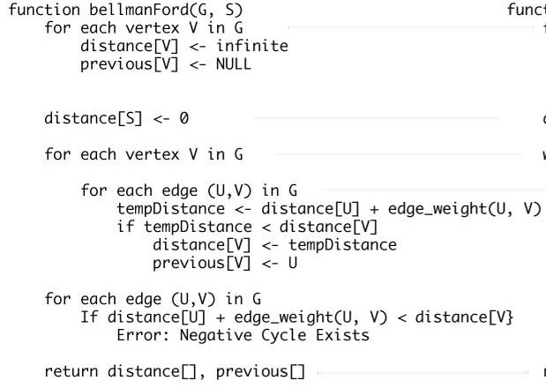

FEATURES:

* + The graph vertices are connected through the adjacency list which are very flexible to alter and append. New currencies can be added to cover the major currencies available.
  + User friendly GUI is made in which he/she can just enter his/her currency and submit to view if a path is available for him/her to gain profits. Path shown is also in well-structured form.
  + The project contains three graphs which have negative cycles formed in different forms.
* Negative cycle in between two vertices.
* Negative cycle in between three vertices.
* No negative cycles possible.

FEATURES OF DST IMPLEMENTED:

**Graph**

The graph discrete structure is implemented by making connections between the currencies (vertices) and denoting them as conversion ratios (edge values). The connections made and the edges entered are through the adjacency list.

BIBLIOGRAPHY



[**https://en.wikipedia.org/wiki/Bellman%E2%80%93Ford_algorithm**](https://en.wikipedia.org/wiki/Bellman%E2%80%93Ford_algorithm)

[**https://www.geeksforgeeks.org/bellman-ford-algorithm-dp-23/**](https://www.geeksforgeeks.org/bellman-ford-algorithm-dp-23/)